Contents
1.Short description 2
2.Dataset 2
3. Solution 2
3.1 Data preprocessing 2
3.2 Object detection 3
3.2.1 ResNet50 3
3.2.2 YOLO 4
3.3 Metrics 6
4. Results 8
5. Conclusion 8

Traffic Light Detector

1.Short description
This project implements an object detection pipeline for traffic lights, leveraging PyTorch for model training and OpenCV for image processing. The system is designed to detect traffic lights in images, classify their color (red, yellow, green), and provide bounding boxes for each detected object. It is designed for autonomous systems

2.Dataset
The dataset is derived from CCF BDCI and is designed for traffic light detection and color classification. It contains 2600 manually labeled traffic light annotations spanning 9 categories: motor vehicle signal light, non-motor vehicle signal light, left-turn non-motor vehicle signal light, crosswalk signal light, lane lights, direction indicator light, flashing warning light, crossing signal light, and U-turn signal light.
The dataset includes 3000 dashcam images in the image folder and 2600 JSON annotation files in the anno folder. Each annotation file stores bounding boxes and labels in JSON format, and visualizations show lights of the same color consistently colored across images.

Solution
The project begins with data preprocessing, where images are loaded, resized, and normalized, and annotations are converted into bounding boxes and class labels compatible with PyTorch. A Faster R-CNN with a ResNet-50 backbone is used as the object detection model, trained to predict both traffic light locations and colors. During training, the model optimizes a combination of bounding box regression loss (Smooth L1) and classification loss (cross-entropy). For evaluation, bounding box accuracy is measured using IoU metrics, and classification performance is reported using per-class accuracy or overall accuracy. Visualizations of predictions help verify the model’s detection quality on test images.

3.1 Data preprocessing
The project uses a custom PyTorch dataset to load traffic light images and annotations. JSON annotation files are parsed to extract bounding boxes and color labels, with "background" assigned to unannotated regions. Images are resized according to a resize_factor, converted to RGB, normalized to [0, 1], and converted to CHW tensors . During training, targets include boxes, labels, area, iscrowd flags, and image IDs, all in PyTorch tensor format, ready for use with Faster R-CNN. For testing, only the processed images and filenames are returned.

Object detection
Object detection is the process of finding objects in an image and classifying them. For each detected object, the model outputs:
- Bounding box → location of the object (x_min, y_min, x_max, y_max)
- Class label → what type of object it is (e.g., red light, green light, background)
Model Workflow
- Feature Extraction: The image is passed through a backbone network (like ResNet-50) to extract high-level features.
- Region Proposal Network (RPN): The model predicts candidate object regions, called proposals, based on the features. These are areas likely to contain objects.
- RoI Pooling / Align: Each proposed region is cropped and resized into a fixed-size feature map for further processing.
- Classification and Regression Heads: Classification head predicts the object class (e.g., red, green, yellow, or background). Bounding box regression head predicts refined box coordinates for more precise localization.
- Non-Maximum Suppression (NMS): Overlapping boxes for the same object are removed, keeping the most confident detection.

ResNet50
Faster R-CNN is a popular deep learning model used for object detection which involves identifying and localizing objects within an image. Building on earlier models like R-CNN and Fast R-CNN, Faster R-CNN introduced a significant improvement by incorporating a Region Proposal Network (RPN) that generates object proposals directly within the model. This integration makes it faster and more accurate allowing it to detect multiple objects in real time with high precision.
Architecture
- Backbone: The backbone is usually a deep CNN like VGG16, ResNet or ResNeXt, it’s used for feature extraction and these feature maps are shared by both the RPN and the detection network.
- Region Proposal Network: RPN is a small network sliding over the feature map, that predicts bounding boxes and scores
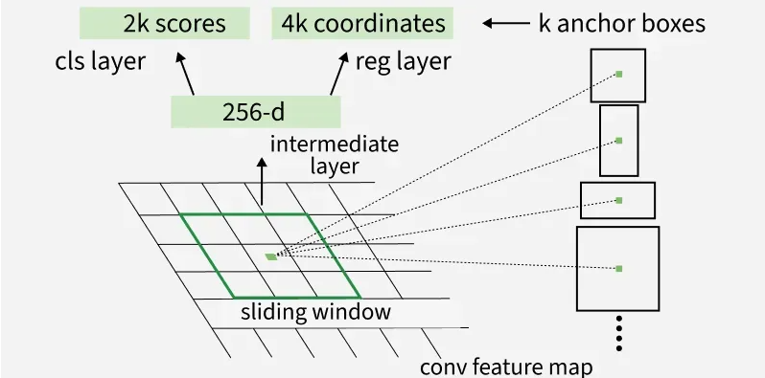

- Region of interest (ROI) pooling: Converts the proposed regions of varying sizes into a fixed-size feature map for the detection network.
- Detection network: Classifies each proposed region into object categories, refines bounding boxes for precise localization, uses softmax or classification and smooth L1 loss for bounding box regression.
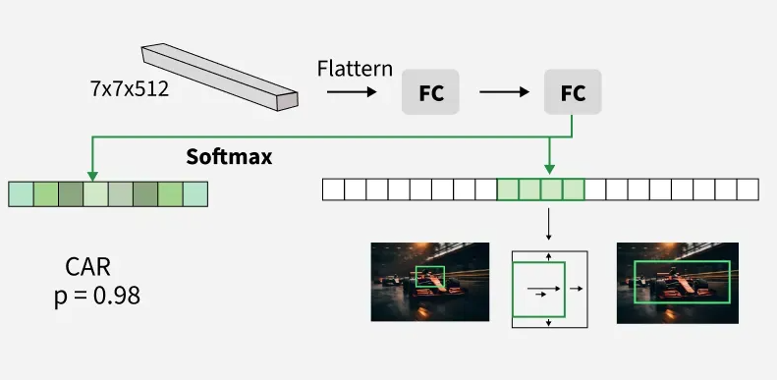

YOLO
YOLO was proposed by Joseph Redmond et al. in 2015 to deal with the problems faced by the object recognition models at that time, Fast R-CNN was one of the models at that time but it had its own challenges such as that network could not be used in real-time because it took 2-3 seconds to predict an image and therefore could not be used in real-time. Whereas in YOLO we have to look only once in the network i.e. only one forward pass is required through the network to make the final predictions.
Arhitecture:
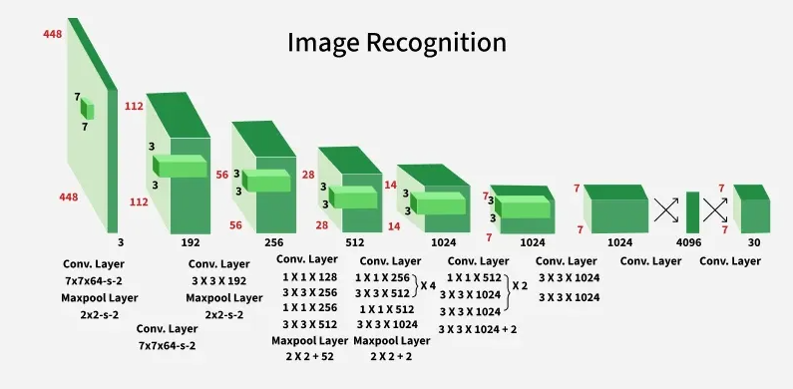
- Input Preprocessing: The model accepts an image as input. It resizes the input image to 448×448 pixels ensuring that the aspect ratio is preserved using padding. This ensures uniformity of input dimensions across the network which is essential for batch processing in deep learning.
- Backbone convolutional Neural Network (CNN): After preprocessing the image is passed through a deep CNN architecture designed for object detection: the model consists of 24 convolutional layers and 4 max-pooling layers, these layers help in extracting hierarchical spatial features from the image.
- Use of 1x1 and 3x3 convolutions: To reduce the number of parameters and compress channels, 1×1 convolutions are employed and these are followed by 3×3 convolutions to capture spatial patterns in the feature maps.
- Fully connected layers: Following the convolutional layers, the architecture has 2 fully connected layers. The final fully connected layer produces an output of shape (1, 1470).
- Cuboidal Prediction Output: The output vector of size 1470 is reshaped to (7, 7, 30).
- Activation Functions: The architecture predominantly uses Leaky ReLU as its activation function.
- Output Layer Activation: The last layer uses a linear activation function, suitable for making raw predictions like bounding box coordinates and confidence scores.
- Regularization techniques: Batch Normalization is employed across layers to stabilize and accelerate training, dropout is also incorporated to prevent overfitting by randomly deactivating neurons during training, encouraging the network to learn more robust features.

3.3 Metrics
F1 score
F1 Score is a metric used to evaluate the performance of a classification model. It combines precision and recall into a single value and is especially useful when the dataset has imbalanced classes.
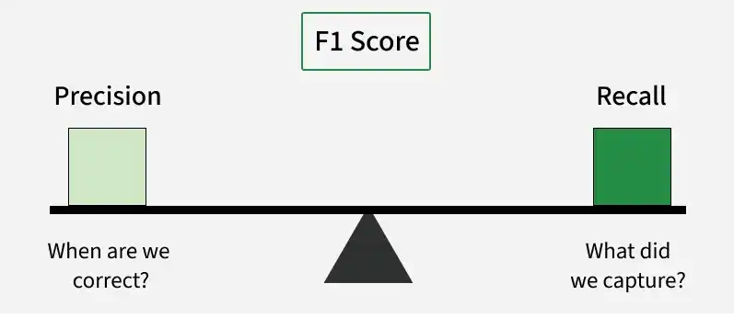
Components:
- Confusion Matrix: A confusion matrix is a table used to evaluate the performance of a classification model. It compares the actual labels with the predicted labels to show how many predictions were correct or incorrect.
- Precision: Precision measures how many of the positive predictions made by the model are actually correct. It tells us how accurate the model is when it predicts a positive class.
- Recall: Recall, also known as Sensitivity or True Positive Rate, measures how many of the actual positive cases were correctly identified by the model. It focuses on the model’s ability to detect positive instances.
F1 Score combines precision and recall into a single metric using the harmonic mean. It helps evaluate a model by balancing both precision and recall.
F1 in multi-class classification
In a multi-class classification, where there are more than two classes, the F1 score is calculated separately for each class instead of using a single score for the whole model. This is commonly done using the One-vs-Rest (OvR) or One-vs-All (OvA) approach. Steps:
- Treat one class as positive: For each class, consider it as the positive class and all other classes as negative.
- Calculate metrics per class: Compute precision, recall and F1 score using TP, FP and FN for that class.
- Combine the results: The individual F1 scores can be combined using micro-average, macro-average or weighted average to get an overall performance measure.

Mean average precision(mAP)
AP (Average precision) is a popular metric in measuring the accuracy of object detectors like Faster R-CNN, SSD, etc. Average precision computes the average precision value for recall value over 0 to 1.
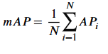
IoU (Intersection over union)
IoU measures the overlap between 2 boundaries. We use that to measure how much our predicted boundary overlaps with the ground truth (the real object boundary). In some datasets, we predefine an IoU threshold (say 0.5) in classifying whether the prediction is a true positive or a false positive.

Choice:
I chosed mAP as metric for performance because:
- Threshold Independence: F1-Score requires you to pick a specific confidence threshold (e.g., 0.5). If you change it, the score changes. mAP evaluates the model across all possible thresholds, giving you a global view of its performance.
- Localization Precision (IoU): mAP is often calculated at different IoU (Intersection over Union) levels (like mAP@.50 or mAP@.75). This tells you not just "did I find the object," but "how tight is my bounding box?" F1-Score doesn't naturally account for this spatial accuracy.

Results
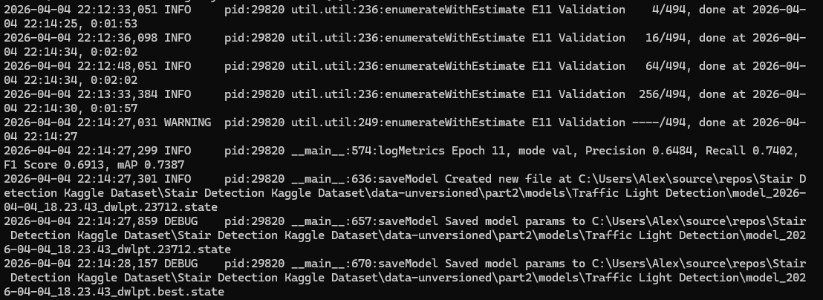
- Precision (0.6484): Of all the traffic lights your model thought it found, ~65% were actually traffic lights.
- Recall (0.7402): Of all the traffic lights that exist in the images, your model successfully found ~74% of them. This tells you how many missed it.
- F1 Score (0.6913): This is the harmonic mean of Precision and Recall. Since your Precision and Recall are somewhat far apart (~10% difference), the F1 score gives you a single "balance" number to track overall quality at a fixed confidence threshold
- Localization Quality: With an mAP of 0.7387, the model demonstrates that it doesn't just find the lights, but it places the bounding boxes accurately around them, which is vital for calculating the distance to the light.

Conclusion
The model has great performances, but there are a some solutions to increase the mAP and to avoid overfitting:
  - Increase the number of epochs: By increasing the number of epochs, we can get a better mAP of 0.8-0.9
  - Data augmentation: By augmenting the data, we can reduce overfitting, but this thing means a big number of epochs because it will be harder for the model to learn.
  - Layers freezing: By freezing during the first epochs the backbone layer and train only the heads, the model will not forget learned features from pre-training. In the second part is recommended to unfreeze the backbone, but with a small learning rate.
  - Model changing: The model can pe changed, for example, RetinaNet, MobileNet, Yolo, can trained and compared which one has better mAP to be later deployed on a server or an Edge Device

